EMERGENCY CONTACT LIST
IN THE CASE OF
ACCIDENT OR EMERGENCY

Ambulance | 000
Fire | 000
Police | 000
Doctor or  Medical Centre | 9319 5999
Poisons  Emergency | 131 126
Gas Emergency | 131 909
Electrocution | 000
WorkCover NSW | 13 10 50
Environmental Protection Authority | (02) 9995-5000
First Aiders | Jerry Lerotic
First Aiders | 0417 293 816
 | Gary Woods
 | 0437 406 272
 | Paul Cameron
 | 0421 051 101

EMERGENCY
PHONE CALL
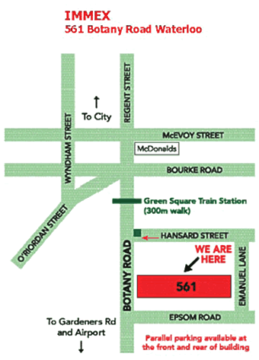

STATE:

- I HAVE AN EMERGENCY TO REPORT

- YOUR NAME

- PROJECT NAME/ADDRESS

- TYPE OF EMERGENCY

- DON’T HANG UP UNTIL ASKED TO DO SO

- ANSWER ALL QUESTIONS

THE PROJECT NAME AND ADDRESS IS:
WaterDeliveryAlliance, MUDDY CREEK, Riverine Park
West Botany street ,
Enter driveway opposite Spring st
Arncliffe, NSW

Local Medical Clinic
Immex Occupational Medicine
561 Botany rd, Waterloo
02 9319 5999

Closest Hospital
St. George Private Hospital
1 South Street, Kogarah, NSW, 2217
9598-5555

